**BUSINESS LOGO**

**ULTRASONIC TEETH BRUSHING :SALON TERMS AND CONDITIONS**

**PRICING STRUCTURE**

**Pay as you Go:**

* CONSULTATION – 1ST VISIT (1hr) £40 includes the head
* SUBSEQUENT VISITS/MAINTENANCE(30 mins) £25 each

**Pre-Paid:**

* PRE-PAID INTRODUCTORY OFFER(x10) £250 includes the head

Includes the Initial consultation plus 9 subsequent visits & the brush head

**TERMS & CONDITIONS:**

* The method of ultrasonic teeth cleaning is highly effective in removing tartar, improving gums, breath odour and overall oral health, \*\***BUSINESS NAME\*\*** cannot guarantee the results, effectiveness or suitability for individual pets due to varying external factors. If dogs become distressed or we discover anything likely to cause discomfort to your pet, we will discontinue immediately. The best approach to solve this will then be discussed with you.
* Each pet will have its own tooth brush head that will not be used on another dog. The initial tooth brush head will be supplied as part of your initial consultation and it will need be replaced after approx. 25 treatments or sooner if required. Some pets may chew the brush head, if this is excessive it may need replacing sooner to maintain effectiveness. Brush heads will require replacing after 1 year regardless of number of times they have been used.

Toothbrush heads cost £7.50 each to replace.

* If we feel any teeth are loose or at risk of becoming loose when the tartar comes off we may request you get your pets’ teeth checked at your veterinarian before treatment. It is possible that the tartar build up will be too great and then a veterinary dental may be necessary initially and then follow up with maintenance visits with us.
* \*\***BUSINESS NAME\*\*** cannot be held responsible for any problems occurring from poor dentition before, during or after any teeth cleaning treatments.
* \*\***BUSINESS NAME\*\*** ultrasonic teeth brushing using the Emmi-Pet is not a veterinary procedure and \*\***BUSINESS NAME\*\*** cannot diagnose any veterinarian problems with your dog’s mouth. Please have any concerns checked by your veterinarian.
* \*\***BUSINESS NAME\*\*** offer 2 types of treatment plans:
  + The cost of the *pay as you go subsequent/maintenance* treatments visits will be charged at each appointment.
  + The cost of the *pre-paid plan / oral routine treatment* must be paid in full at the initial consultation.

I understand that the effectiveness of the ultrasonic teeth brushing using the Emmi-Pet is based on **frequency** and that optimum oral health might only be achieved by keeping to the frequency recommended by \*\***BUSINESS NAME**.**

By signing these Terms and Conditions I confirm that I have read and fully understand all the information \*\***BUSINESS NAME\*\***  has provided to me.

Print Name: _________________________________

Signature: _________________________________

Date: _________________________________

**OFFICE USE ONLY:**

**INITIAL CONSULTATION NOTES:**

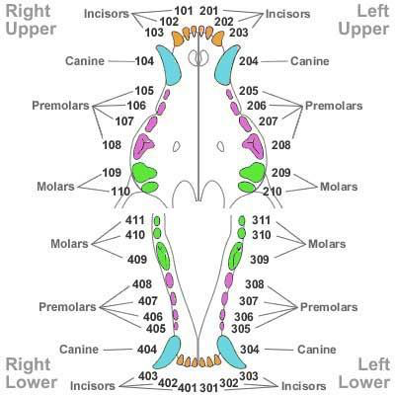

|  |
| --- |
|  |
|  |
|  |
|  |
|  |
|  |
|  |
|  |

**FOLLOW UP NOTES/OUTCOME:**

|  |
| --- |
|  |
|  |
|  |
|  |
|  |
|  |